STUDENTS: SHUT IT DOWN FOR PALESTINE
NOV. 9
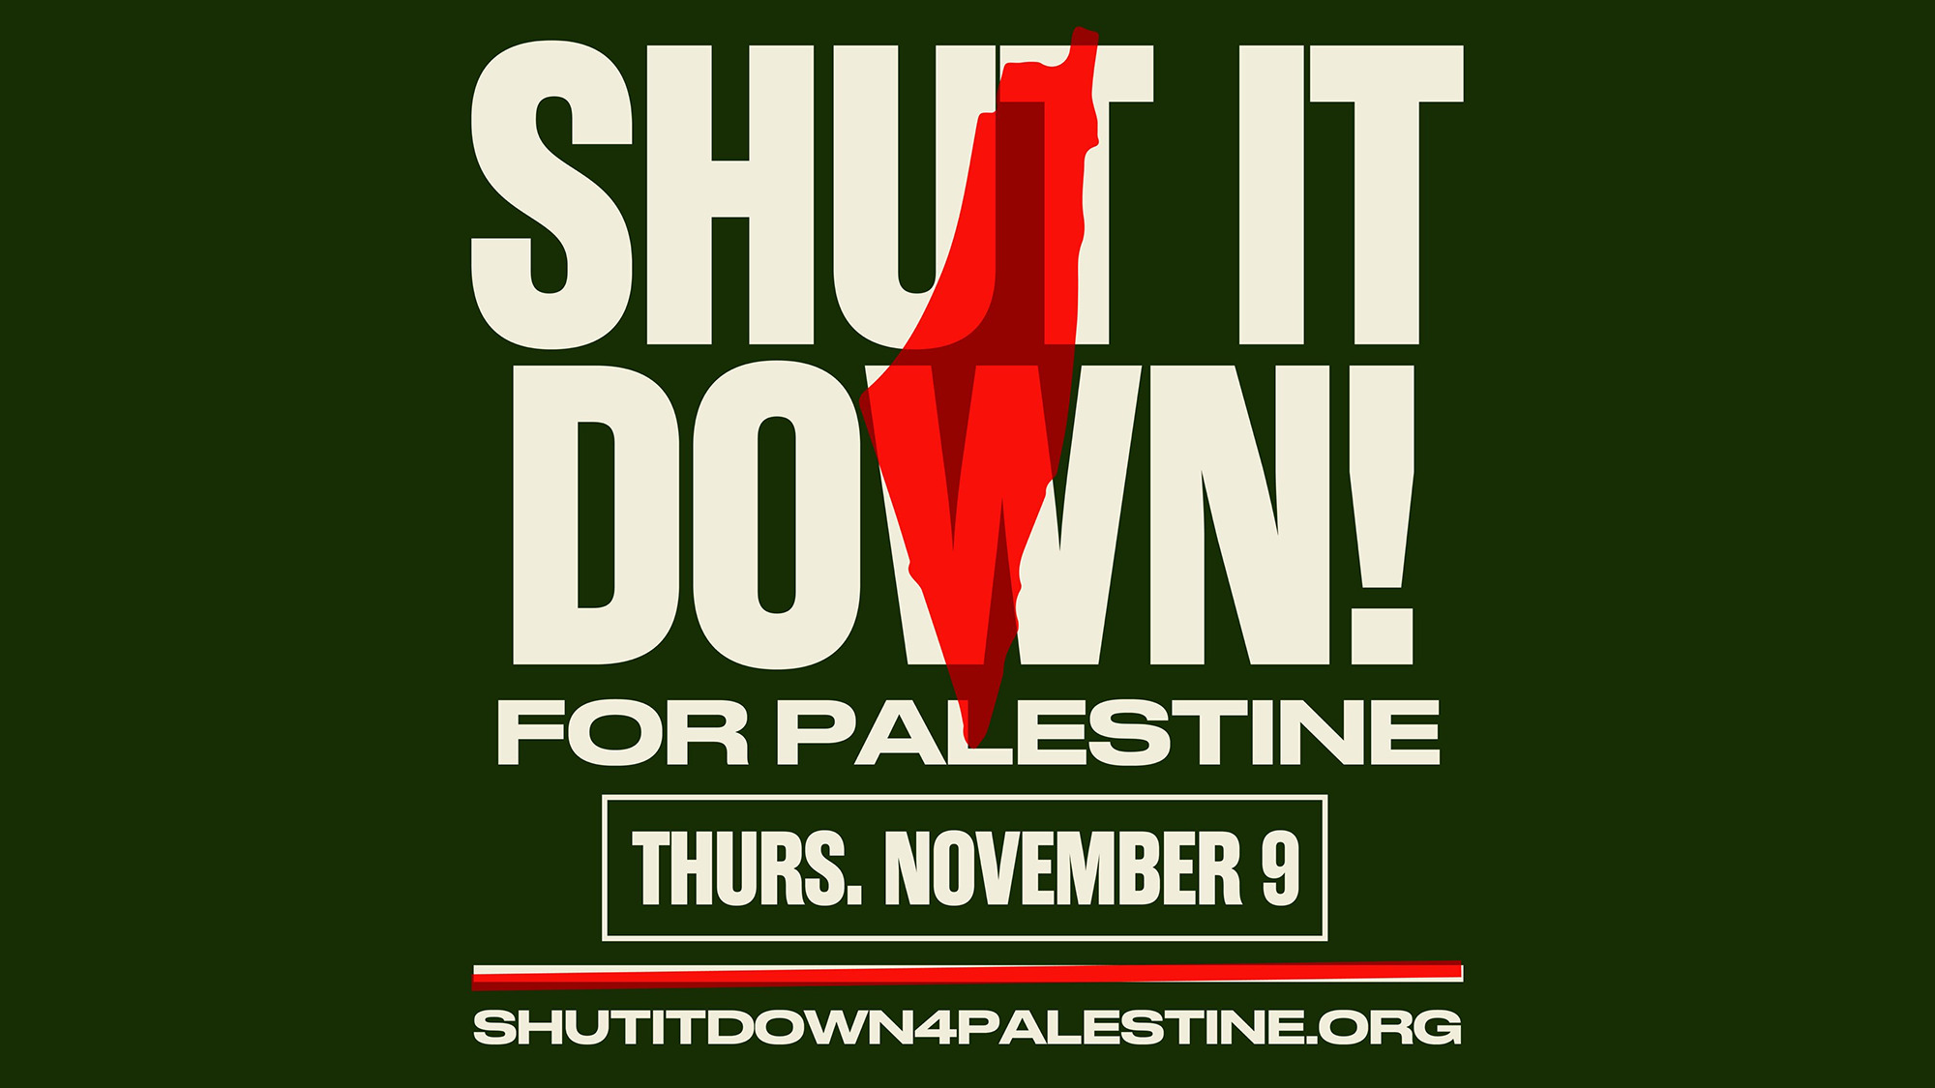

Dissenters | National SJP | PYM

CONTENTS
INTERNATIONAL CALL TO ACTION
OUR DEMANDS
PLANNING YOUR ACTION
OUTREACH
SAFETY PLANNING
RESOURCES
Chants
Press & Media Tips
TIPS ON TALKING TO MEDIA
APPENDIX

INTERNATIONAL CALL TO ACTION
There is a growing global movement for a Free Palestine. Across the world, millions of people are engaging in demonstrations and organizing major marches in solidarity with Palestine. Our demands for an immediate ceasefire, cutting all aid to Israel, and lifting the siege on Gaza have broader support than ever. On November 4th, over 300,000 gathered in Washington DC for the largest march in recent times to stand in solidarity with Palestine. Protests with half a million people erupted on the streets of London, constituents across Canada occupied over 17 MP offices from coast to coast, and Belgian dock workers' unions have refused to transport weapons by plane or sea that are destined for Israel. We must keep building momentum and increase the pressure with more marches, walk-outs, sit-ins, and other forms of direct action directed at the political offices, businesses, and workplaces that fund, invest, and collaborate with Israeli genocide and occupation. NOW is the time for our mobilizations to grow in size, frequency, and focus; building a political climate that makes Israel’s business of genocide unsustainable.
Already protesters have shut down highways, train stations, and bridges in the United States; activists have targeted Israeli weapons manufacturers; Belgian dock workers’ unions have refused to handle weapons transports to Israel; Bolivia has cut diplomatic ties with Israel while Jordan, Chile, and Colombia have recalled their Israeli ambassadors. Be part of the change, take action, and make your voice heard as the global struggle for Palestine enters a new phase.
Join the Shutdown for Palestine this Thursday, November 9, 2023. We call on movements, organized labor, youth, students, media and healthcare workers, and all members of society to join us in demanding an immediate ceasefire, cutting all aid to Israel, and lifting the siege on Gaza. This call to action begins on November 9, but we will continue to build up the momentum with ongoing days of action. No business as usual until Palestine is Free!
- Walk out from work and/or school
- Picket Israeli embassies and consulates
- Picket against companies that profit from Israel’s occupation of Palestine (Lockheed Martin, Boeing, Raytheon, Northrop Grumman, General Dynamics, Elbit Systems)
- Host speak outs
- Wear kuffiyehs

OUR DEMANDS
- We demand an immediate end to Israel’s siege on Gaza and the U.S. military funding to Israel.
- We demand an immediate ceasefire.
- We demand our universities fully divest from weapons corporations which arm Israel’s occupation and genocide in Gaza.

PLANNING YOUR ACTION
What: International Student Walkouts, Teach-Ins & Actions, November 9th

Who: National Students for Justice in Palestine, Palestinian Youth Movement, Dissenters, International Peoples Assembly, Resist US-Led War, students, faculty, staff, parents, community members – everyone!

Tag: @wearedissenters @nationalsjp @palestinianyouthmovement

Where: Universities—and all sectors of society across the country

How:
- Register your action, so we can feel our collective impact
  - Gather your collaborators to plan your walkout.
- Create outreach materials for your action
  - You can make a copy of this template and edit!
- Publicize and recruit students to participate.
  - Create posters, text comrades, and spread the news by word of mouth.
  - Create a list of groups in your school, reach out to as many as you can and ask them to join your planning crew and spread the word (e.g., Student Government, Black Student Union, etc.).
  - Use social media to connect with folks about the walkout. DM people, contact other school clubs, contact students at other schools.
    - Share our video, or create your own with your campus or community-specific “why.”
- Safety
  - Gather your collaborators to form a safety team that will decide security protocols and make major decisions on the day of the walkout. See SAFETY PLANNING below for more information.
- Know your rights.
  - National Lawyers Guild (NLG) know your rights guides in six languages
  - Vision/Change/Win and NLG: know your rights during COVID-19
  - Electronic Frontier Foundation (EFF): guide to surveillance self-defense & digital security
  - EFF’s digital guide to attending a protest
  - ACLU know your rights video
  - ACLU know your rights around immigration
  - Mutant Legal: the dissident’s survival guide

OUTREACH
To students:

(A) Text message

Hello [insert name]! Invitation for you—our campus is participating in an international day of action on Thursday Nov. 9th. We’re calling for a ceasefire in Gaza, and for our school to divest from the companies arming the Israeli occupation and genocide of the Palestinian people. We will take action at [insert time] at [insert location] onThursday. Will you join us?
After confirming support:
- Share action toolkit
- Follow-up
(B) Email/Long form post:

Hey [insert name],

Join our call for an international walkout THURSDAY, 11/9, to call for an end to the US-backed siege on Gaza and U.S. military funding and arms to Israel.
Our institutions are investing in the genocidal siege of Palestine. Their money, words, and programs make Israel’s occupation and violence possible.
They try to silence us, because they need us to be afraid, confused, and divided. But we, as a united movement for Palestinian liberation, choose to dissent. We have the power and the duty to force our institutions to end support for Israeli occupation.
We are rising up 🇵🇸✊🏽🌊 This Thursday, November 9th, [insert org name] invites you to join us for a day of walkouts — a day of movement building, action, and solidarity for the liberation of Palestine, and all oppressed people here and around the world.
Every year, U.S. war profiteers — Boeing, Lockheed Martin, Northrop Grumman, General Dynamics, and Raytheon — fuel violence here and abroad by arming violent regimes in Israel, the Philippines, and local police departments across the United States. We choose to dissent. We call for an end to the genocidal siege on Palestine.
We call on our community to walk out of class on Thursday November 9th to #ShutItDown4Palestine and to demand that our university divest from the war industry and invest in what our communities actually need to be safe.

Will you join us?
[sign off]

After confirming support:
- Share action toolkit
- Follow-up

To faculty:

Dear [insert name],

In solidarity with the Palestinians in Gaza and the call for an international day of walkouts on November 9, I am requesting that you refuse to do any work for the university (e.g. cancel class; refuse to provide asynchronous class material; refuse to record materials on Thursday, November 9th, or engage in any other form of academic labor, such as answering emails) in observance of the walkout. As someone who takes teaching and learning seriously, I do not make this request lightly, but I believe the November 9th walkout represents an important learning opportunity for ourselves and our students as to what it means to act in solidarity with the Palestinians facing bombardment, genocide, apartheid. I urge you to show your support by refusing to cross the picket line.

In solidarity,

[Sign off]

Non-retaliation letter:

Dear [Department] students,

As the [insert position], I write in support of the International Day of Walkouts on Thursday November 9th, 2023. In solidarity with those mobilizing for Palestinian lives, I support faculty, staff, and student decisions to join the nationwide call for a one-day work stoppage on November 9th to end the siege on Gaza. I recognize that many of our Palestinian, Arab, Black, Brown, and Indigenous students have faced racist attacks intended to dehumanize them. We must acknowledge Islamophobia and white supremacy are present in our culture, which renders all members of campus and our surrounding communities unsafe. I am committed to a campus that advances racial justice by challenging all forms of xenophobia, and I support students working towards this vision.

The Department of [insert name] will not retaliate against undergraduate or graduate students who join the Palestinian solidarity events happening nationwide on October 25 or beyond for exercising their first amendment rights. Further, I/we/the department oppose(s) any threat of retaliation that may come from the administration, and stand beside our students in the struggle for racial justice and a more livable university environment for all.

I am disappointed that the university has not yet taken substantive action to support Palestinian students in the face of incontrovertible evidence regarding the dehumanization they are facing. I call on the [CAMPUS] administration to substantively respond to the calls for divestment from war profiteers.

In solidarity/in community
Chair of [insert department]

Proposed syllabus language:
I am committed to a campus that advances justice, and I support students, staff, and faculty working towards this vision. Students participating in the nationwide actions on 11/9 will not be penalized in this class.

Proposed out of office reply:

In solidarity with the movement to end the siege on Gaza and the call for international day of walkouts on November 9th, I am out of the office and I will not cross the picket line.

For Twitter
- RISE UP WITH US 🇵🇸✊🏽

International Day of Walkouts to #ShutItDown4Palestine
Thursday November 9th

Join us to demand an end to the US-backed siege on Gaza!

[attach image]
- On Thursday, November 9th, we are calling on students and all sectors of society across the country to participate in an international day of action, calling on our schools and institutions to divest from Israel’s occupation and genocide of the Palestinian people.
- On November 9th, [insert org name] is calling on the entire campus community to walk out of class to demand an end to Israel’s genocide of Gaza, a ceasefire, and to stop war profiteering at our university. Join us. 🇵🇸✊🏽
- Students are facing unprecedented repression and backlash from Zionist groups and administrators on our campuses. Our universities are censoring and intimidating those who take a stand for Palestine. We won’t back down, and we got your back

For Facebook & Instagram
Our institutions are investing in the genocidal siege of Palestine. Their money, words, and programs make Israel’s occupation and violence possible.
They try to silence us, because they need us to be afraid, confused, and divided. But we, as a united movement for Palestinian liberation, choose to dissent. We have the power and the duty to force our institutions to end support for Israeli occupation.
Join our call for an international walkout THURSDAY, 11/9, to call for an end to the US-backed siege on Gaza and U.S. military funding and arms to Israel.
We are rising up 🇵🇸✊🏽🌊 This Thursday, November 9th, [insert org name] invites you to join us for a day of walkouts — a day of movement building, action, and solidarity for the liberation of Palestine, and all oppressed people here and around the world.
Every year, U.S. war profiteers — Boeing, Lockheed Martin, Northrop Grumman, General Dynamics, and Raytheon — fuel violence here and abroad by arming violent regimes in Israel, the Philippines, and local police departments across the United States. We choose to dissent. We call for an end to the genocidal siege on Palestine.
We call on our community to walk out of class on Thursday November 9th to #ShutItDown4Palestine and to demand that our university divest from the war industry and invest in what our communities actually need to be safe.
🇵🇸Join us.
✊🏽Dissent.
🌊We will turn the tide.

SAFETY PLANNING
Assessing Risk:

“There can be no consequential action that does not accept risk...If there were such a thing as an action that produces real change without real risk, there would be no reason not to do it—and people would thus have done it already, bringing about the change in question…if we want consequential change for all, we must accept risk.

“Respect the risk tolerance of others. Political struggles and social movements often arise from communities with sustained experience of risk and repression. This may lead to risk aversion; it just as commonly leads to a readiness for direct action. Anti-police movements provide perhaps the clearest example of this. The most under threat are often the most committed to revolutionary struggle. Solidarity with such movements begins not in taking jobs as risk managers but in struggling alongside to the best of your capacities...

“There is nothing more high-risk than delay. The risk will simply be shifted onto someone else.” - Reflections on Risk from UC Cops Off Campus (see full statement at the link)

Form a safety team to help your group assess, mitigate and stay vigilant about the risks of taking action on and off campus:
The safety team decides on security protocols and makes major decisions on the day of the action. Here are some roles to consider if you are planning a large action and have a lot of folks ready to help out. (If you don’t have a lot of folks, that’s ok! Try to fill as many as possible.)

Security Coordinator: The point person of the security team, makes decisions on formation changes, de-escalation tactics, and participates in tactical team decisions. Sometimes trains the team before the action or event.

Program Point: This is a non-security role. This person generally coordinates speakers, performances, and any other elements of the program. Program Point is an important part of the Tactical Team because this person knows the run of the show and can help to shift or end the program depending on security needs.

Police Negotiator: The designated person to interact with police, show permits (if needed), and communicate between tactical and police. Generally, this role is used to ‘buy time’, support the action or event to meet the goal, and anticipate and reduce potential arrests. This person does not directly concede to police requests, does not give any information to police, and does not escalate police.

Marshall: These are the eyes and ears of a security team. There is usually one marshall for every 20 participants, depending on the level of risk. Marshalls hold the perimeter for the action and act as a buffer between the police and participants. Some marshalls may be trained in physical de-escalation.

.: A security team larger than 10 people should have captains in order to relay information quickly and maintain discipline and coordination. Captains are responsible for relaying information to a group of as few as three to as many as eight marshalls.

Lookouts: Two to four people who run the perimeter of the action to relay information and communication from one end of the action to the other. Runners can also be used to scout potential concerns such as oncoming traffic or police presence.

Legal Support: A lawyer who is on-call (and off-site) to advocate for the release of anyone who is arrested during the action.

Legal Observers: A team (generally one for every 15 participants) who records all police activity and DOES NOT intervene in physical or verbal incidents. Usually wears different clothing to distinguish from the security team.
- Contact your local National Lawyers Guild chapter to invite Legal Observers to your protest or to find a representative for someone arrested at a protest.

De-escalators: These are generally highly skilled folks whose role is to intervene in physical violence. They can be officially a part of security or roaming the crowd, depending on conditions.
- Tips:
  - If there are police or other militarized forces present, you should be ready for them to escalate the situation at any point.
  - Keep your crew close and know where you want to meet up if separated.
  - If things start to escalate, try to stay calm, take a breath and look around to get your bearings if you are able to safely do so. Consider if you need to leave the area.
  - If police are moving the crowd in a certain direction, be mindful that they might be preparing to use “crowd control” tactics such as teargas, rubber bullets, or might be trying to corner you to make arrests.
  - Consider sitting down if you are with a group that can sit together and if safe to do so, this can sometimes slow police advances.

RESOURCES
- If your organization or student group needs additional resources, action planning, or campus backlash support, submit a request to NSJP’s Campus Support Coalition.
- If your chapter or student group needs additional support to plan and execute your action(s), fill out Dissenters Support Form.
- Direct students facing Zionist harassment to Pal Legal’s intake form.
- Chapters | National Lawyers Guild
- Harassment Protection for Students and Academics
- Know Your Rights — Palestine Legal
- Get in Formation: A Community Safety Toolkit
- Safety Training --Shareable
- TO SHARE De-Escalation Handout
- Tips for Digital Security
- Civil Disobedience at Public Universities from the ACLU of Northern California
- Security Culture for Activists Toolkit from The Ruckus Society for more tips!
- Know-your-rights tips:
  - While the police will not always protect or respect your rights, you should still invoke them by saying the below words in the following situations.
    - If you are stopped by law enforcement, say: Am I being detained or am I free to leave?
    - If the police try to search you, say: I do not consent to a search.
    - If the police try to question you, say: I wish to remain silent and I want to talk to a lawyer.
  - If law enforcement does not immediately respect these rights, continue to invoke them.

Chants:
Chants are a great way to engage your audience and share your message. Below are chants that are used widely during demonstrations in support of Palestine.

Tips:
- Practice these chants out loud before the walkout
- Assign chant leads.
  - There are people who can keep energy up, have good rhythm, and can get the crowd going! (Reminder: this is a skill that can be developed over time.)
- Use amplified sound! A megaphone or mic is key for you to engage your audience
- Print out some copies (or make a QR code) of the chants you want to use at your action. This will help your chant leads remember all the chants.
- You know your school best! Pick the chants that you are confident saying and think will work best for your audience.

Call (response)
- Free free Palestine (Free Free Palestine)
- Long Live Palestine (Long Live Palestine)
- Viva viva Palestina (Viva viva Palestina)
- From Palestine to Mexico (From Palestine to Mexico )
These border walls have got to go (These border walls have got to go)
- From Palestine to the Philippines (From Palestine to the Philippines)
Stop the US war machine! (Stop the US war machine!)
- What do we want? (JUSTICE!) – When do we want it? (NOW!)
- The people, united, can never be defeated
- When Palestine is under attack. What do we do? (Stand up, Fight Back)
- Israel Israel you can’t hide - (We charge you with genocide)
- Stop bombing Gaza! Stop bombing Gaza!
- Every time the media lies (a neighborhood in Gaza dies)

Press & Media Tips

A mass media advisory should be sent out the morning before your action, preferably at 6AM when journalists and reporters are being assigned stories for the day. If you have the information, consider also calling the “news” or “assignment” desks of major networks after the email is sent. Those quick calls can be divided amongst early risers, and might go something like this:

“Hi, I just wanted to know if you received the press release from [name of person who sent the email] about the [school] pro-Palestine student protest happening at [time] today?”
→ If they say yes, ask if they plan to send anyone. [they’ll probably say that they will see if they can assign it in their newsroom meeting later]
→ If they say no, ask them if they could send someone. [if they ask “what email?”, provide them with the email it was sent from}
Refer to the press release to answer any other basic questions they might have (location, start time, visuals). If they ask for a quote when you call because they say they aren’t sure if they can send someone, say NO. Refer them to the press release where there are quotes provided!

Voice Message: Hello! I am calling to check if you received an email this morning at [time] from [name/email] with a press release concerning a [school] pro-Palestine student protest happening today at [protest time] at [location]. I was calling to check in to see if you received this email, and if you can send anyone to cover the event— feel free to reach out to the numbers or email addresses listed on the press release with any further questions. Thank you!

You may also choose to release an “embargoed” press release with any trusted media connections. In this case, you would send them your media contacts & the press release ahead of the action, and ask them to refrain from releasing the information before a specific time or date. This gives them time to call your media contacts and write a story ahead of time. Instead of “immediate release,” you would write “the information in this press release is embargoed until [date, time].”

TIPS ON TALKING TO MEDIA
From #CareNotCops at UChicago.

- Reporters may try to ask you questions that are meant to trip you up. Stick to the script and the main talking points!
- Be aggressive and make sure the question you want to be asked is asked, even if you have to ask it yourself. Don’t wait until the reporter asks you the question you want to answer. The question might never come. Instead, use another question to segue into the topic you want to discuss. For example, “What really matters is ____.” Or “The most important issue is ______,” or “The more interesting question is______.”
- Stay away from answers that are too technical. When you talk above people’s heads, you drive them away. Answer as simply as possible, without jargon. You don’t need to know all the details.
- Stick to what a reporter asks and what you want to say. There’s no need to volunteer additional information. This goes back to planning what your goals are for the interview. You should know what it is that you’d like to communicate from the start, and stick to that information as much as possible. More is not better. Answer questions briefly. When you give long-winded answers, you give the power to the journalist to choose what parts of what you said to use and what to omit.
- If you don’t know the answer to a question, just say so. There’s nothing wrong with saying you don’t know, that there hasn’t been a decision yet, or that you aren’t sure of the answer and need to check and will get back to the journalist.
- Don’t stress out about interviews! At the end of the day, media outlets will tell the story they want to tell, but we are also creating our own narrative through our own documentation + social media. Take this as a learning opportunity!

Press Resources:
- how to prepare for an interview with a print publication
- handling hostile interviews. There are some examples that are from a few years back, but the principles and guidance remain evergreen.
- pivoting in an interview

APPENDIX

Here are some ways you can take action. Click the links to see more details about each tactic.

- Rally + March
- Letter Delivery
- Call In Action
- Vigil / Altar Build

- Walkout
- Cafeteria / Student Center Disruption
- Bird-Dogging
- Sit-in / Occupation
- Blockade

Letter Delivery
A tactic where participants deliver a letter or other document to a target or set of targets. The letter may be linked to a petition or otherwise be representative of the will of the people.

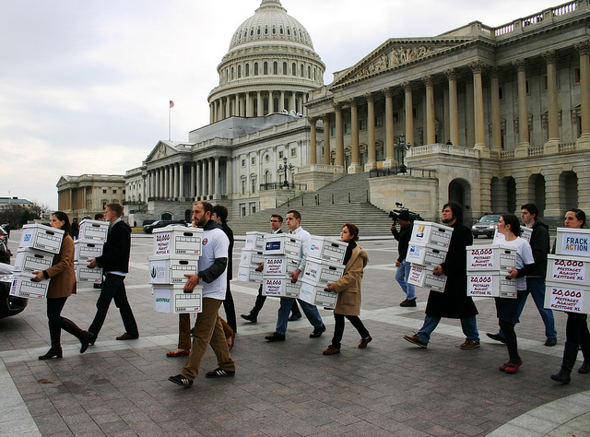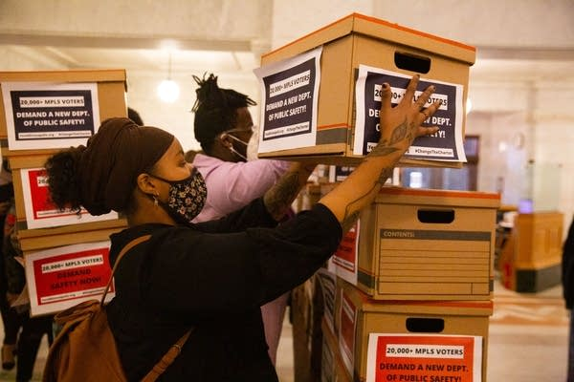

Resources: Beautiful Trouble - Creative Petition Delivery

Cafeteria/Student Center Disruption
An opportunity to amplify your message on campus by disrupting busy spaces to make an intervention on business as usual.

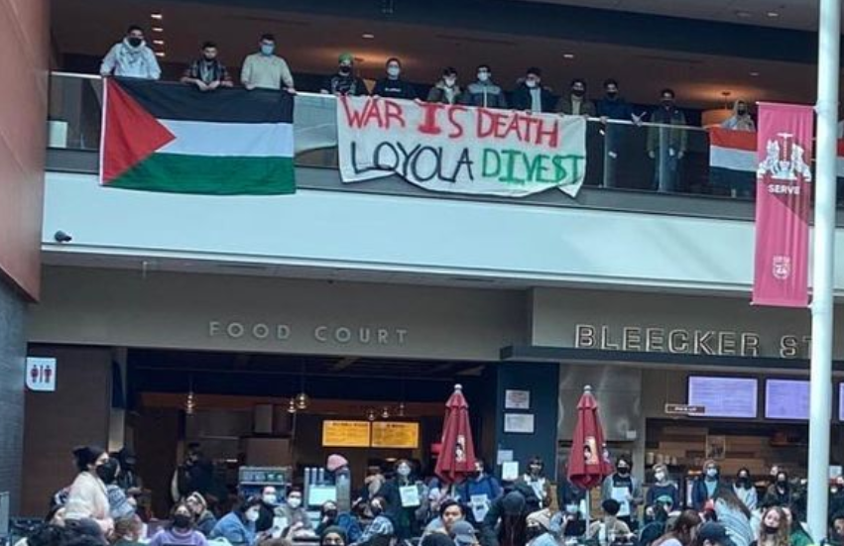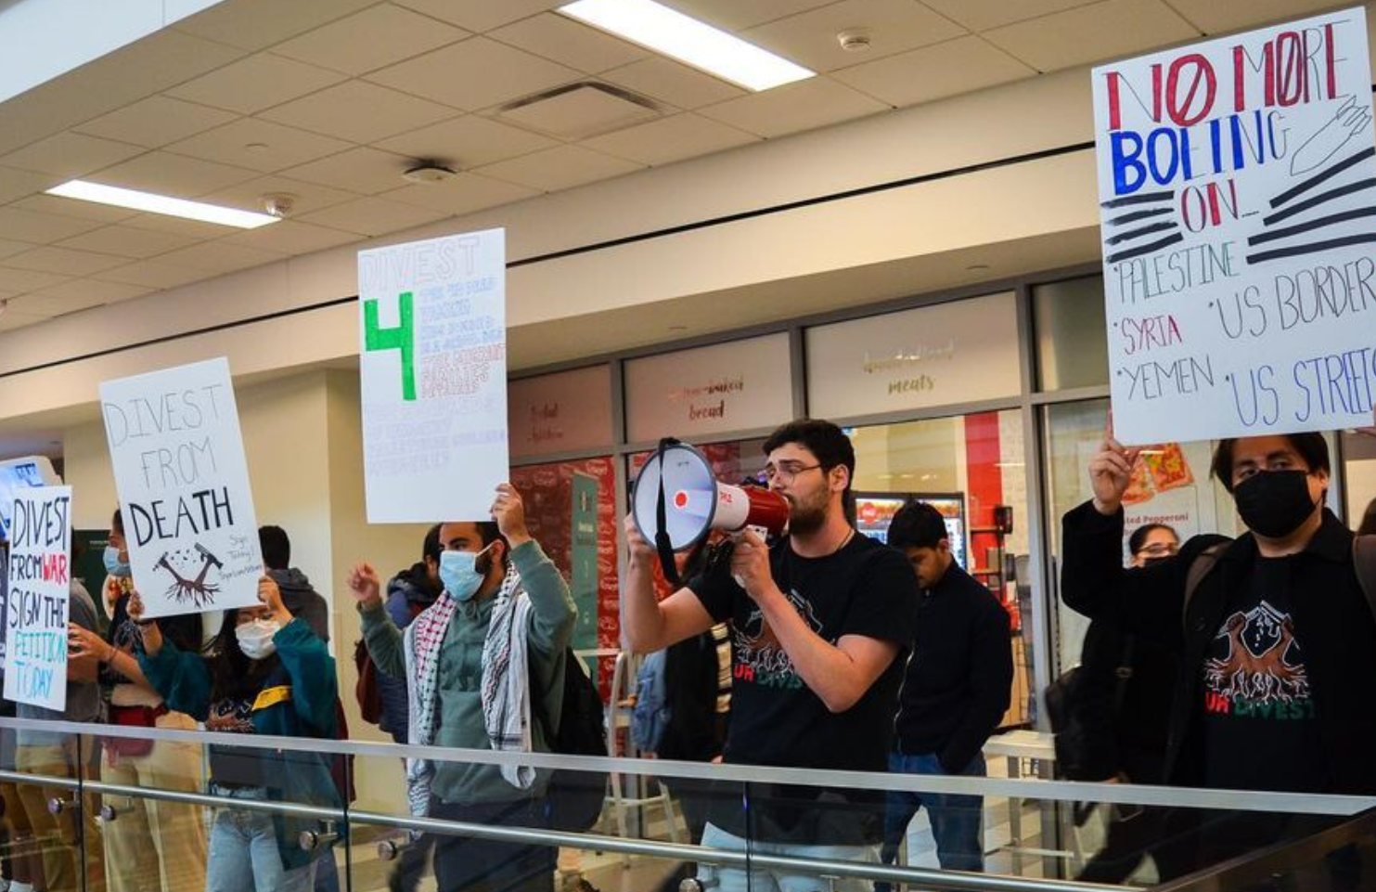

Resources: Beautiful Trouble - Creative Disruption
#BlackBrunch Manual

Blockade
A tactic where participants block access to a location. Blockades may be formed with peoples’ bodies, bodies attached to various kinds of equipment, and/or simply objects that are difficult to remove (e.g. heavy objects or lots of a different kind of object).

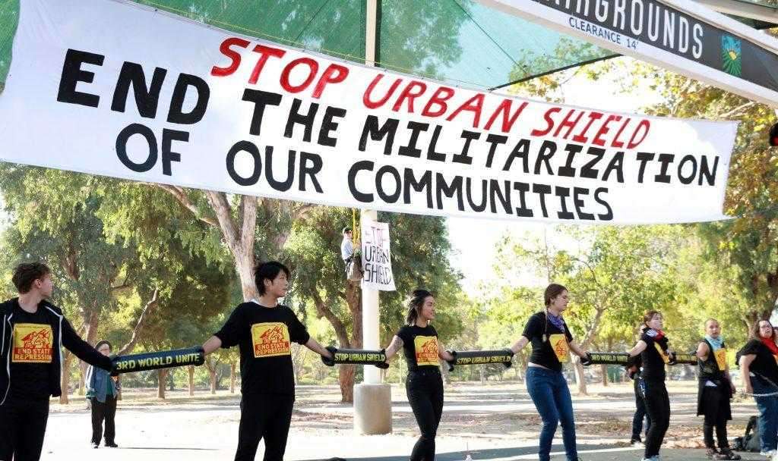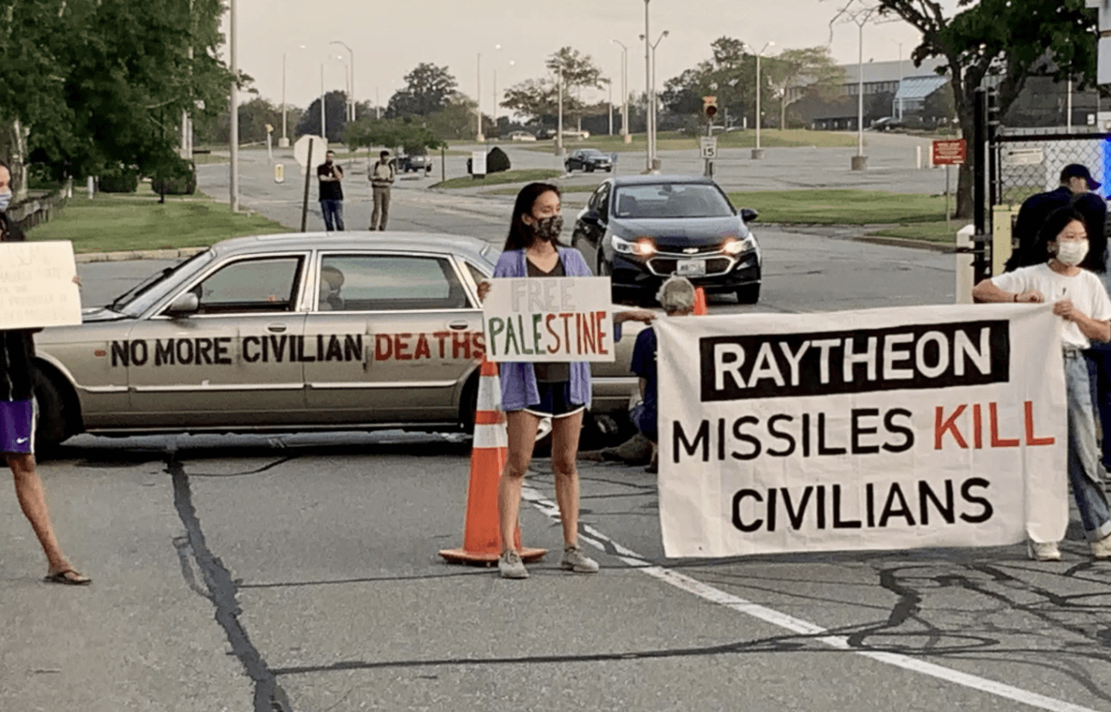

Resources: Beautiful Trouble - Blockade
Destructibles - Lockboxes
The Ruckus Society - A Tiny Little Blockades Booklet

Sit-in / Occupation
The occupation of a space of significance to the target by action participants. These actions may have a predetermined length or continue until the target meets the demands.

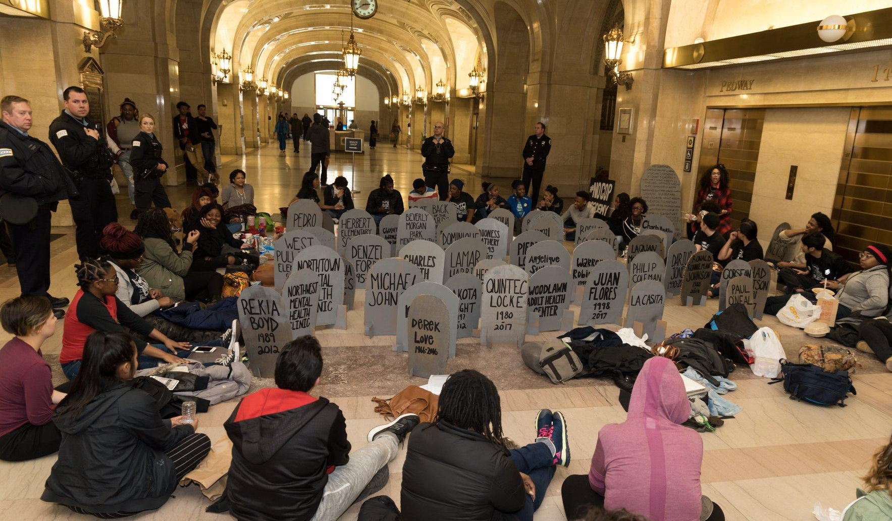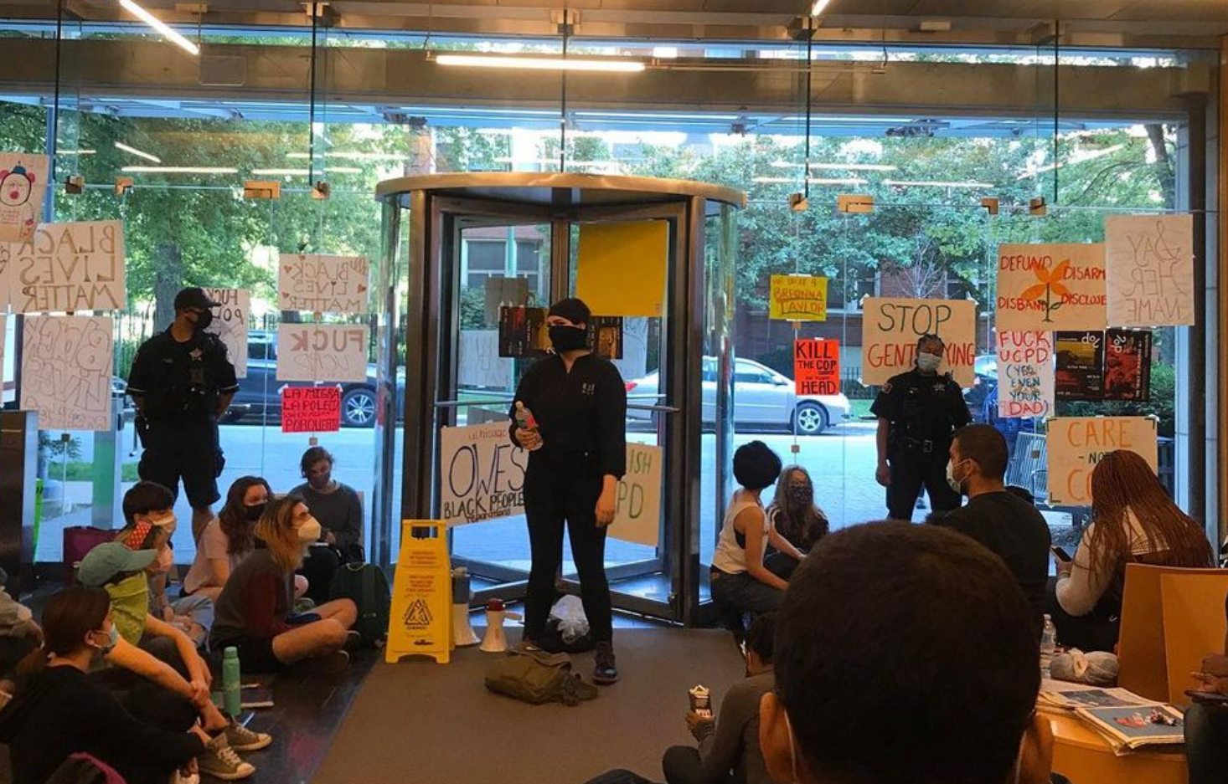

Resources: Beautiful Trouble - Occupation
UltraViolet Guide to Sit-Ins

Walkout
A tactic in which participants, typically students or faculty, walk out of their classes while school is in session in order to join a larger action calling attention to the issue.

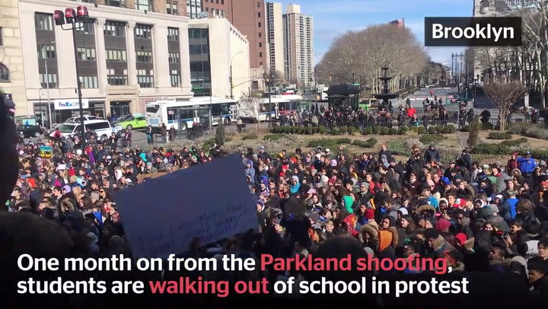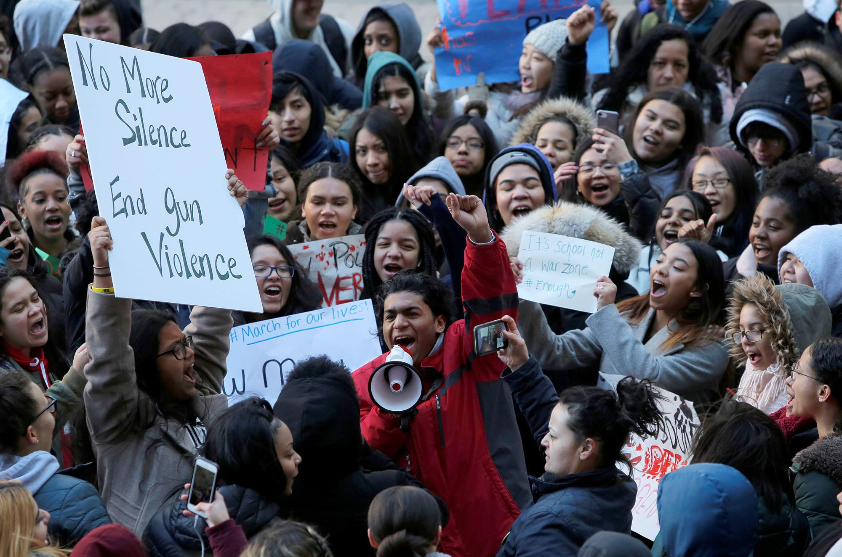

Resources: Beautiful Trouble - Distributed Action

Bird-Dogging
A tactic in which participants pursue their target wherever they are in order to force the target to pay attention or respond to their issue. This usually involves gathering some information on where your target might be when (e.g. speaking engagements, meetings, or other events) and/or familiarizing yourself with your targets’ routines. The same person or persons does not need to be present at each instance of bird-dogging for it to be effective, so long as the messaging is consistent.

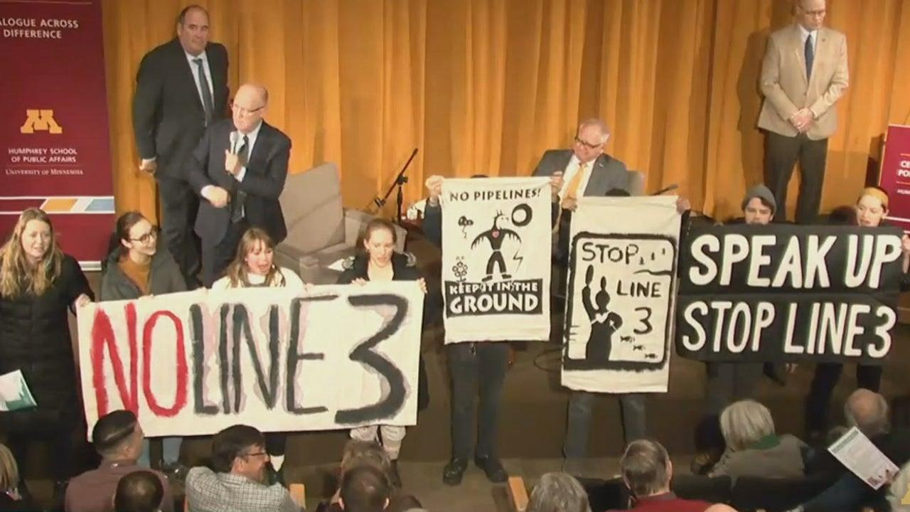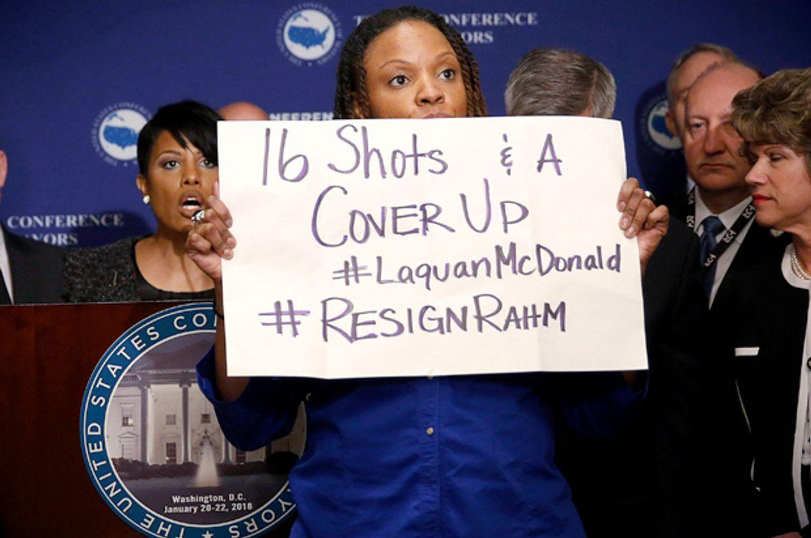

Resources: Backbone Campaign - Bird-Dog Manual (Excerpt)
Beautiful Trouble - Media Jacking
Center for Biological Diversity - How to Bird Dog

Call-In Action
A tactic in which participants call targets nonstop, forcing them to pay attention to the issue. This is an accessible action that many people can participate in, regardless of location.
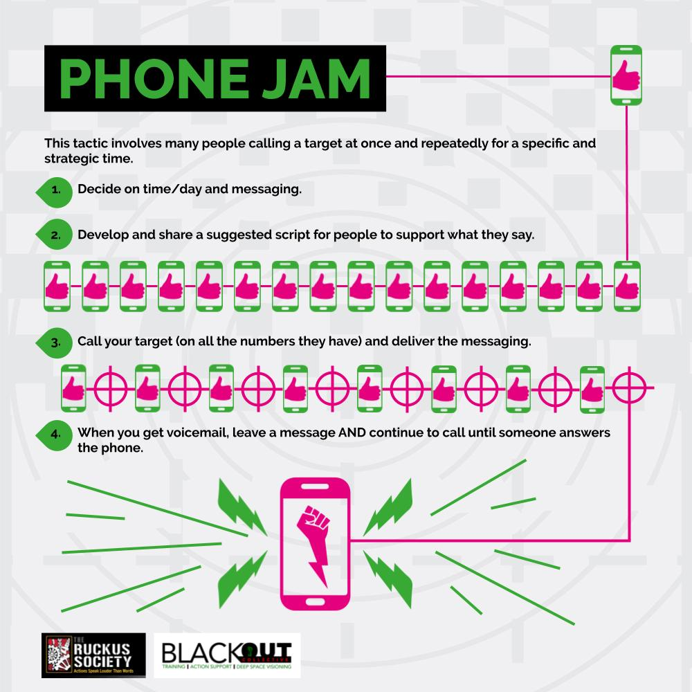

Resources: Beautiful Trouble - Phone Banking
Beautiful Trouble - Phone Blockade

Vigil / Altar Build
Mourning and remembrance as protest. The creation of a physical sacred space (e.g. an altar) in order to remember those whose lives have been lost due to the issue at hand. Altars may be standalone or accompanied by a vigil, which typically involves speaking and/or activities that those present may take part in.
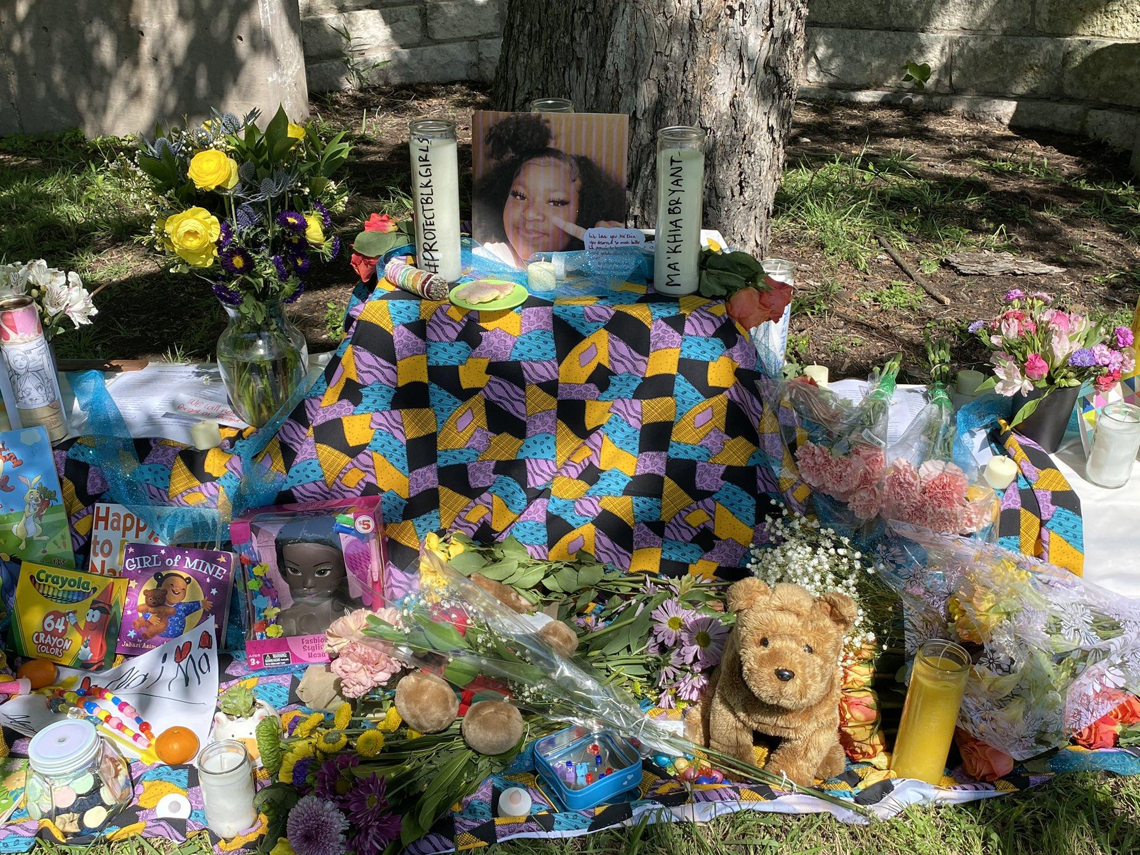

Resources: Beautiful Trouble - Artistic Vigil
Beautiful Trouble - Lamentation
Black Feminist Future - Community Altar Building Toolkit

Check out this slideshow of examples, tips, and resources for more inspiration!

Students: Forward this letter to your department’s chair, the graduate/undergraduate director, or a sympathetic professor and ask them to adopt this statement. Faculty can show support on a class by class basis (syllabus language can be found below), but truly effective solidarity must be structural and must happen at the departmental level.
Source: Get in Formation: A Community Safety Toolkit

